Grenadier Bar Snacks

Dishes | 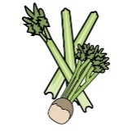 | 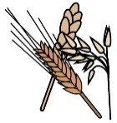 | 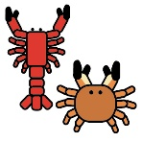 | 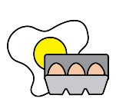 | 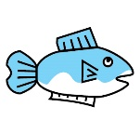 | 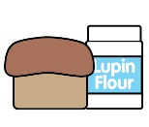 | 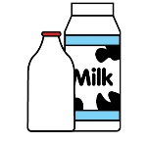 |  | 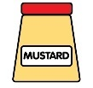 | 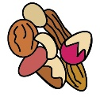 | 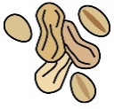 | 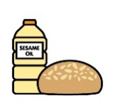 |  | 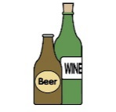
 | Celery | Cereals containing gluten | Crustaceans | Eggs | Fish | Lupin | Milk | Mollusc | Mustard | Nuts† | Peanuts | Sesame seeds | Soya | Sulphur Dioxide
Scotch egg | NO | YES | NO | YES | YES | NO | YES | NO | YES | NO | NO | NO | YES | YES
Sausages | NO | YES | NO | NO | YES | NO | NO | NO | YES | NO | NO | NO | NO | YES
Truffle and Parmesan Chips/Fries | NO | YES | NO | NO | YES | NO | YES | NO | NO | NO | NO | NO | NO | NO
Olives | NO | NO | NO | NO | NO | NO | NO | NO | NO | NO | NO | NO | NO | YES
Duck leg croquettes | YES | YES | NO | YES | YES | NO | YES | NO | NO | NO | NO | NO | NO | YES
Sausage Roll | YES | YES | NO | YES | YES | YES | YES | NO | NO | NO | NO | NO | NO | YES
Scampi | NO | YES | YES | YES | YES | NO | YES | NO | NO | NO | NO | NO | NO | NO

Review date: |  | Reviewed by:

Grenadier starters Menu

Dishes
 | Celery | Cereals containing gluten | Crustaceans | Eggs | Fish | Lupin | Milk | Mollusc | Mustard | Nuts† | Peanuts | Sesame seeds | Soya | Sulphur Dioxide
Soup of the day | YES | YES | NO | NO | NO | NO | YES | NO | NO | NO | NO | NO | NO | YES
Smoked salmon | NO | YES | NO | NO | YES | NO | YES | NO | NO | NO | NO | NO | NO | YES
Goats cheese tart | NO | YES | NO | NO | YES | NO | YES | NO | YES | NO | NO | NO | NO | YES
Chicken Parfait | NO | YES | NO | NO | NO | NO | YES | NO | YES | YES | NO | NO | NO | YES
Scallops | NO | YES | NO | NO | NO | NO | YES | YES | NO | NO | NO | NO | NO | NO
Parma Ham Asparagus | YES | YES | NO | YES | NO | NO | YES | NO | YES | NO | NO | NO | NO | YES

Review date: |  | Reviewed by:

Grenadier Main Menu

Dishes
 | Celery | Cereals containing gluten | Crustaceans | Eggs | Fish | Lupin | Milk | Mollusc | Mustard | Nuts† | Peanuts | Sesame seeds | Soya | Sulphur Dioxide
Beef Wellington | YES | YES | NO | YES | NO | NO | YES | NO | NO | NO | NO | NO | NO | YES
Cod | NO | YES | YES | YES | YES | NO | YES | YES | NO | NO | NO | NO | NO | YES
Grenadier Burger | YES | YES | NO | YES | NO | NO | YES | NO | YES | NO | NO | YES | YES | YES
Fish and Chips | NO | YES | NO | NO | YES | NO | YES | NO | YES | NO | NO | NO | NO | NO
Lamb Rump | YES | NO | NO | NO | NO | NO | YES | NO | NO | NO | NO | NO | NO | YES
Curry | YES | YES | NO | NO | NO | NO | NO | NO | YES | NO | NO | NO | NO | NO
Breaded Chicken | NO | YES | NO | YES | NO | NO | YES | NO | NO | NO | NO | NO | NO | NO
Wild mushroom Gnocchi | NO | NO | NO | NO | NO | NO | YES | NO | YES | YES | NO | NO | NO | YES

Review date: |  | Reviewed by:

Grenadier Sides Menu

Dishes
 | Celery | Cereals containing gluten | Crustaceans | Eggs | Fish | Lupin | Milk | Mollusc | Mustard | Nuts† | Peanuts | Sesame seeds | Soya | Sulphur Dioxide
Chips/ Fries | NO | YES | NO | NO | YES | NO | NO | NO | NO | NO | NO | NO | NO | NO
Truffle Chips/ Fries | NO | YES | NO | NO | YES | NO | YES | NO | NO | NO | NO | NO | NO | NO
Garden salad with honey mustard dressing | NO | NO | NO | NO | NO | NO | NO | NO | YES | NO | NO | NO | NO | YES
Broccoli | NO | NO | NO | NO | NO | NO | YES | NO | NO | YES | NO | NO | NO | NO

Review date: |  | Reviewed by:

Grenadier Dessert Menu

Dishes
 | Celery | Cereals containing gluten | Crustaceans | Eggs | Fish | Lupin | Milk | Mollusc | Mustard | Nuts† | Peanuts | Sesame seeds | Soya | Sulphur Dioxide
Sticky Toffee | NO | YES | NO | YES | NO | NO | YES | NO | NO | NO | NO | NO | NO | NO
Panna cotta | NO | NO | NO | NO | NO | NO | YES | NO | NO | NO | NO | NO | YES | YES
Chocolate Fondant | NO | NO | NO | YES | NO | NO | YES | NO | NO | NO | NO | NO | YES | NO
Cheese Board | NO | YES | NO | NO | NO | NO | YES | NO | NO | NO | NO | NO | NO | YES
Ice cream | NO | NO | NO | YES | NO | NO | YES | NO | NO | NO | NO | NO | NO | NO
Sorbet | NO | NO | NO | NO | NO | NO | NO | NO | NO | NO | NO | NO | NO | NO
Cheescake | NO | YES | NO | YES | NO | NO | YES | NO | NO | NO | NO | NO | NO | YES

Review date: |  | Reviewed by:

Grenadier Roast Menu

Dishes
 | Celery | Cereals containing gluten | Crustaceans | Eggs | Fish | Lupin | Milk | Mollusc | Mustard | Nuts† | Peanuts | Sesame seeds | Soya | Sulphur Dioxide
Roast Pork | YES | YES | NO | YES | NO | NO | YES | NO | NO | NO | NO | NO | NO | YES
Beef Wellington | YES | YES | NO | YES | NO | NO | YES | NO | NO | NO | NO | NO | NO | YES
Vegan Beetroot roast | YES | YES | NO | NO | NO | NO | NO | NO | NO | NO | NO | NO | NO | YES
Yorkshire puddings | NO | YES | NO | YES | NO | NO | YES | NO | NO | NO | NO | NO | NO | NO

Review date: |  | Reviewed by:

